ITUMELENG MOLEPO ST10519228
XHAW TASK 1.

TASK 1 – PHASE 1
Pawsitive Pet Academy – Pet Care & Training Academy
- Idea/Scenario Choice
Chosen Scenario: Pawsitive Pet Academy
The selected scenario is Pawsitive Pet Academy, a pet care and training facility located in Durban. Sarah Smith founded the academy in 2023.
This business offers hands-on education and training for pet owners, future pet-care professionals, and animal enthusiasts. The website and mobile app will share details about the academy, its courses, fees, contact info, and a cost calculator.
Users can easily explore the available courses, check course specifics, and figure out the total price when choosing multiple classes.
Why Was This Scenario Chosen?
Pawsitive Pet Academy was picked because pet care and animal training provide valuable services that help many people who have or work with animals.
This scenario also allows for creating a system that is informative, easy to use, and practical. Customers need to quickly find information about courses, compare options, and calculate the costs of their chosen classes.
Another reason for selecting this scenario is that it has enough features to showcase various software development skills. The website and mobile app can include:
Information
Images Navigation Menus
Course
Tables
Forms
Input Validation
Fee Calculations
Discounts
VAT Calculations
Contact Information
Google Maps/Directions
Responsive Design
This scenario was chosen because it enables the creation of a realistic system while showcasing knowledge from various modules.
3. Who Is the Client and What Does the Client Want?
Client
The client is Pawsitive Pet Academy, which Sarah Smith established in Durban in 2023.
What Does the Client Want?
The client seeks a website and mobile app that make it easy for customers to find information about the academy and its training programs.
The client wants the system to let customers:
- See details about Pawsitive Pet Academy.
- Learn about the academy’s history, vision, mission, and goals.
- View a summary of all available courses.
- Access detailed information on individual courses.
- Check the duration and fees for each course.
- Choose one or more courses.
- Calculate the total cost for selected courses.
- Receive the correct discount based on how many courses they choose.
- Calculate 15% VAT.
- View a quote that shows selected courses and the total amount due.
- Find contact details for the academy.
- Locate the physical address of the training venue.
- Access social media links.
- Navigate smoothly between different pages or screens. The client wants the website and mobile app to offer similar features and easy navigation so that users enjoy a consistent experience on both platforms.

- What is User-Centered Design?
User-centered design (UCD) is a method of creating a system that focuses on the needs, expectations, skills, and experiences of the people who will use it.
For Pawsitive Pet Academy, we will build the website and mobile app with pet owners, future pet-care professionals, and animal lovers in mind.
The system must be:
- User-friendly – users should easily figure out how to navigate the website and app.
- Easy to learn – users should quickly grasp how to view courses and calculate fees.
- Accessible – information should be clear and available for various types of users.
- Consistent – both the website and mobile app should have similar navigation and content.
- Responsive – the website should function well on different screen sizes.
- Error-tolerant
- Group Roles Assigned – 2 Marks
I worked on this assignment by myself. So, there were no other group members to give roles to. I took on all the responsibilities needed for the project.
My roles included:
Project Manager – I planned and organized the project. UI/UX Designer – I created the layout, color scheme, and logo for the website and mobile application. Web Developer – I built the website using HTML, CSS, and JavaScript. Mobile Developer – I developed the mobile application with Java and XML in Android Studio. Tester – I checked the website and mobile application for errors and fixed them. Documentation Manager – I wrote the report and documented my work. Version Control Manager – I handled the project files and managed the GitHub repository.
- Tasks Allocated to Each Group Member
Since I did the project alone, all tasks were mine to complete.
Task Person Responsible Research and planning Myself Scenario selection Myself User-centered design Myself Logo design Myself Color palette Myself Website design and development Myself Mobile application development Myself Database/calculation planning Myself Testing and error handling Myself GitHub repository Myself Report/documentation Myself
I took care of every task from planning through to final development and testing.
3. GitHub Username
Since I worked on this assignment alone, there is only one contributor listed on GitHub.
GitHub Username :itumelengmolepo-hue
GitHub Repository: https://github.com/itumelengmolepo-hue/pawsitive-pet-academy.git
I used GitHub to save and manage my project files. It also helped me back up my work and keep track of the changes I made during development.
Important: Make sure to replace the brackets with your actual GitHub username and repository link. Do not create a fake username or link.
4. Group Agreement Document
As I completed the assignment by myself, there was no need for a group agreement since multiple members were not involved. I took full responsibility for the entire project and decided to handle all tasks on my own.
Individual Project Agreement
I confirm that I finished the Pawsitive Pet Academy project by myself. I managed everything, including planning, research, design, development, testing, documentation, and submission of the project.
I agreed to:
- Complete all assigned tasks independently.
- Manage my time effectively to meet deadlines.
- Keep my project files organized.
- Test both the website and mobile application.
- Fix any errors found during development.
- Maintain my GitHub repository.
- Ensure the final project meets all assignment requirements.
- Submit my own original work.
Student Name: Itumeleng Molepo
Student Number: st10519228
Signature: I.Molepo__________
Date: 4 September____________
Brief overview of the report
I worked on this project by myself, so there were no teammates to sign a group agreement. Instead, I made an individual project agreement where I took on all responsibilities and tasks. This covered planning, research, design, development, testing, documentation, and managing GitHub.

TASK 1 – PHASE 3
Pawsitive Pet Academy
1. Best Design Choice
1.1 Scenario Selected
Scenario 1: Pawsitive Pet Academy – Pet Care & Training Academy.
Pawsitive Pet Academy is a pet care and training center founded in Durban in 2023 by Sarah Smith. The academy offers training programs for pet owners, future pet-care professionals, and animal enthusiasts.
I decided to create a website and mobile app for the academy. Both platforms will offer similar information and features but will be tailored to fit the needs of each one.
1.2 Best Design Choice
After exploring various design options, I opted for a clean, simple, and modern design for the Pawsitive Pet Academy website and mobile app.
I chose this design because the main users need to access information quickly. The website and app should be straightforward without any extra or confusing details.
My design features:
- Easy navigation.
- Clear titles and subtitles.
- A noticeable logo.
- A matching color scheme.
- Course cards.
- Tables with course details.
- Buttons for key actions.
- Forms to collect customer information.
- A fee calculator.
- A design that adjusts for various screen sizes.
- A uniform look between the website and the mobile app.

1.3 Parts of the Design That I Chose
Here are the parts I selected for my final design:
Design Part | My Design Choice | Reason
Navigation | Horizontal navigation bar | Helps users find important pages easily
Logo | Pet/paw-themed logo | Symbolizes animals and the academy
Colours | Warm orange, dark grey, and white | Gives a friendly yet professional look
Font | Simple sans-serif font | Easy to read
Homepage | Large hero section | Quickly shows what the academy provides
Courses | Course cards and table | Allows for easy comparison of courses
Buttons | Clear action buttons | Guides users on what to click
Forms | Simple forms | Makes it easier to enter information
Mobile layout | Vertical layout | More suitable for smaller screens
Fee calculator | Step-by-step selection | Simplifies calculations for users

1.4 Why I Chose This Design
I selected this design because Pawsitive Pet Academy is a business focused on animals. I aimed to create an interface that feels friendly and inviting, while still maintaining a professional look.
I also thought about the people who would use the site when making my design decisions. A user should be able to open the website or app and quickly find out:
What the academy offers, what courses they have, their costs, and how to get in touch with them.
Because of this, I made sure not to complicate the design too much.
2. Screenshots of Design Choices, Final Logo and Colour Palette
2.1 Final Logo
For the final design, I created or chose a logo that represents the Pawsitive Pet Academy brand.
This logo will appear in the navigation area of both the website and mobile app. I picked a pet-themed design because it clearly shows that the organization works with animals.
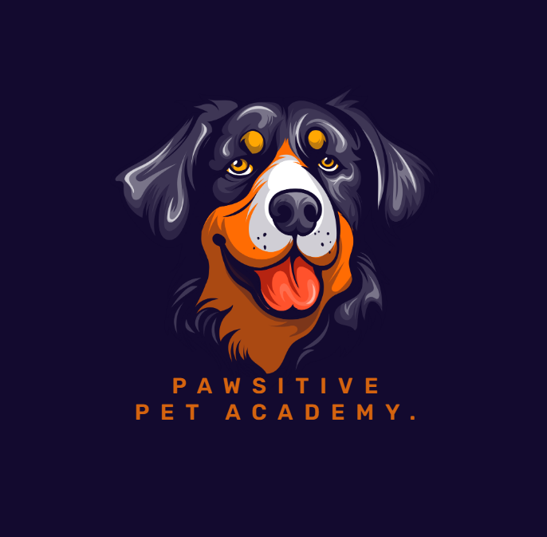
Logo Design Explanation
I chose this logo because it reflects what Pawsitive Pet Academy is all about. The pet image makes it easy for people to recognize the organization.
The logo will be used consistently across the website and mobile app to help build a recognizable brand identity.
2.2 Color Palette
For my project, I picked the following color palette:
Color | Purpose
Orange | Used for buttons and key actions
Dark Grey | Used for navigation bars, headings, and professional elements
White | Used for backgrounds to enhance readability
Light Grey | Used for sections and backgrounds

The main colors are:
Orange
Dark Grey
White
Light Grey
Why I Chose These Colours
I selected orange because it gives the website a warm, friendly, and lively vibe, which is perfect for a pet-care business.
I chose dark grey as it adds a professional look and creates a good contrast with white text.
I used white and light grey to keep the layout neat and avoid making the pages feel cluttered.
I also applied these colours consistently throughout the website to ensure a unified design.
2.3 Final Design Screenshot
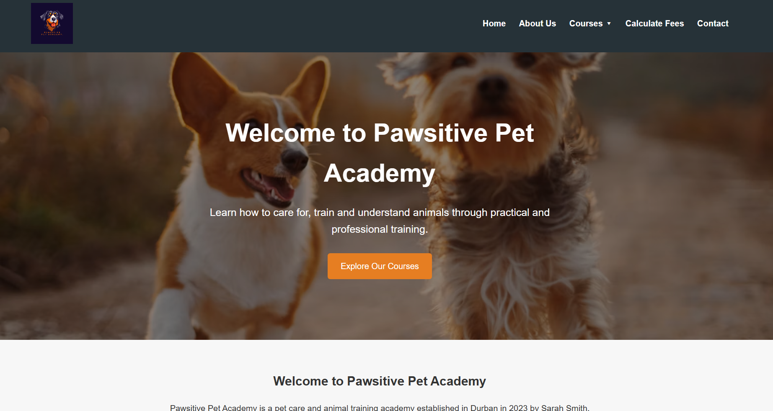
The screenshot must display:
- Logo
- Navigation bar
- Homepage title
- Hero image
- Course button
- Main content area

3. Research on Websites and Mobile Applications
Before I created my website and mobile app, I investigated existing websites and applications to learn how professionals design their systems.
I concentrated on four key areas:
- Navigation
- Screen/page layout
- Responsive design
- User interface design

3.1 Navigation
I examined how various websites and apps arrange their navigation menus.
I discovered that most professional sites place important navigation choices where users can easily find them. Key pages are often included in the main navigation menu.
For my Pawsitive Pet Academy website, I set up the following:
Home
About Us
Courses
Calculate Fees
Contact
Additionally, I added a dropdown menu under Courses so users can quickly reach specific courses.
For instance:
Courses
↓
Canine Obedience Training
Pet Grooming
Animal Behaviour
Pet Business Management
Puppy Care
Pet First Aid
Basic Dog Walking
I selected this navigation format because it helps minimize the time users spend searching for information. For the mobile app, I created a similar navigation setup to ensure users have a steady experience.

3.2 Screen and Page Layout
In my research, I found that websites typically separate information into different sections instead of putting everything on one page.
So, I organized my website into distinct pages:
Home
↓
About Us
↓
Courses
↓
Course Details
↓
Calculate Fees
↓
Contact
The homepage gives a short introduction, while the other pages offer more detailed information.
The courses page features a table and course cards to help make the information clearer.
On the calculator page, users can fill out a form with their details and choose courses.
The contact page includes contact information, a message form, and a map.

3.3 Responsive Design
I investigated responsive design because users access websites on various devices like:
- Desktop computers
- Laptops
- Tablets

